Displaced: 27 Years of Eviction in San Francisco

1. Basic Information
Project Title: Displaced: 27 Years of Eviction in San Francisco
Github: https://github.com/MirandaCavalie/data-vis
Dataset Source: https://data.sfgov.org/Housing-and-Buildings/Eviction-Notices/5cei-gny5/about_data
Dataset Portal: https://datasf.org/opendata

2. Background and Motivation
San Francisco stands at the center of one of the most predominant housing crises in the United States. With a city constrained by geography, restrictive zoning, and decades of underbuilding, the city's rental market has been repeatedly destabilized by waves of economic transformation. The cost of living in San Francisco has risen faster than almost any other metropolitan area in the country, placing enormous pressure on long-term residents; particularly in historically working-class and immigrant neighborhoods. Eviction notices are the most visible symptom of this pressure: they represent moments when the forces of capital and displacement make direct contact with individual lives.

The relationship between San Francisco's tech economy and displacement is well-documented but rarely visualized at scale across time. The city has experienced at least three major displacement waves in the past three decades: the dot-com boom of the late 1990s, when eviction filings peaked at nearly 2,917 notices in 1998; the 2010s tech surge following the IPOs of major companies headquartered in the Bay Area, when filings climbed back toward 2,000 per year by 2015-2016; and the post-pandemic recovery, which has seen filings return to pre-COVID levels.

The motivation also comes from first hand experience. My brother moved to the bay area 5 years ago during 2021 the post pandemic period. He himself has experienced this housing crisis and I have seen first hand coming here to visit through the years how the rent has risen up and his struggles to find actual affordable valuable housing near his workplace. Even though he hasn't experienced an eviction problem he has seen it first hand happen in his surroundings.

Overall, my goal is to use scrollytelling techniques to guide viewers through the full arc of displacement in San Francisco, from the first dot-com boom to the COVID moratorium and its aftermath.

3. Project Objectives
Objective 1: Temporal Trends
How have eviction patterns in San Francisco changed over the past 27+ years? Is it possible to identify spikes linked to economic events such as the dot-com bust (2001), the 2008 financial crisis, the tech IPO boom (2013-2016), and the COVID moratorium (2020)? The visualization will animate a timeline of annual eviction counts and overlay key economic and policy events as annotations.

Objective 2: Geographic Displacement
Which neighborhoods have been most affected by evictions, and how has the geographic distribution of displacement shifted over time across San Francisco's 41 analysis neighborhoods? This visualization could reveal spatial concentrations and show how the epicenter of displacement has shifted across economic cycles.

Objective 3: Eviction Mechanisms
What are the most common legal reasons for eviction and how has the composition of eviction types evolved over time? A stacked area chart linked to the map will decompose eviction counts by reason for each year, revealing shifts in the preferred legal mechanisms landlords use to displace tenants in different eras.

Objective 4: Policy Impact
Can we observe the measurable effect of key housing policies on eviction filing rates? Specifically, can the visualization demonstrate the COVID-19 eviction, and the gradual return to pre-pandemic levels?

4. Data
Dataset: SF OpenData - Eviction Notices
URL: Eviction Notices | DataSF
Portal: https://datasf.org/opendata
Description: The raw dataset contains 48,208 eviction notice records filed with the San Francisco Rent Board, spanning January 2, 1997 through April 1, 2026; nearly 29 years of housing data. After cleaning (dropping 96 rows with missing neighborhood data), the working dataset contains 48,112 records across 32 columns. The dataset is maintained by the San Francisco Rent Board

5. Data Processing:
Cleaning Steps
Data cleaning was done using a custom Python script. The following issues were identified and addressed:
- Date parsing: The File Date column was stored as a string (MM/DD/YYYY format). It was parsed to datetime using pd.to_datetime(). No nulls were found in this column (0 unparseable dates).
- Missing neighborhood data: 96 rows (0.20%) had no value in the Neighborhoods
- Missing address: 14 rows (0.03%) had no street address. These were retained since neighborhood and date data were still present.
- Constraints Date: This column had 90.83% null values and is not used in any visualization
- Duplicate records: Zero duplicate Eviction ID values were found; no deduplication was necessary.
- Boolean columns: The 19 eviction-reason columns were stored as string "true"/"false" values. These were converted to Python booleans using a mapping function

Quantities planned to derive
- Primary reason of eviction
- year / month columns: Extracted from the parsed File Date for use as temporal dimensions in time-series aggregations.
- Annual counts by neighborhood
- Annual reason breakdown

Tools and Libraries

Tool | Purpose
Python | For processing the data
pandas | Data loading, cleaning, groupby aggregation, date parsing
numpy | Array operations, averages
matplotlib / seaborn | Exploratory charts
D3.js | Visualizations (map, charts, animations)

6. Visualization Design

The visualization design follows the Five Design Sheet (FdS) methodology. The process began with a broad idea where I brainstormed possible visualization approaches including choropleth maps, stacked area charts, bump charts, small multiples, and scrollytelling timelines. After filtering and categorizing these ideas I created this 3 layouts.

Layout 1
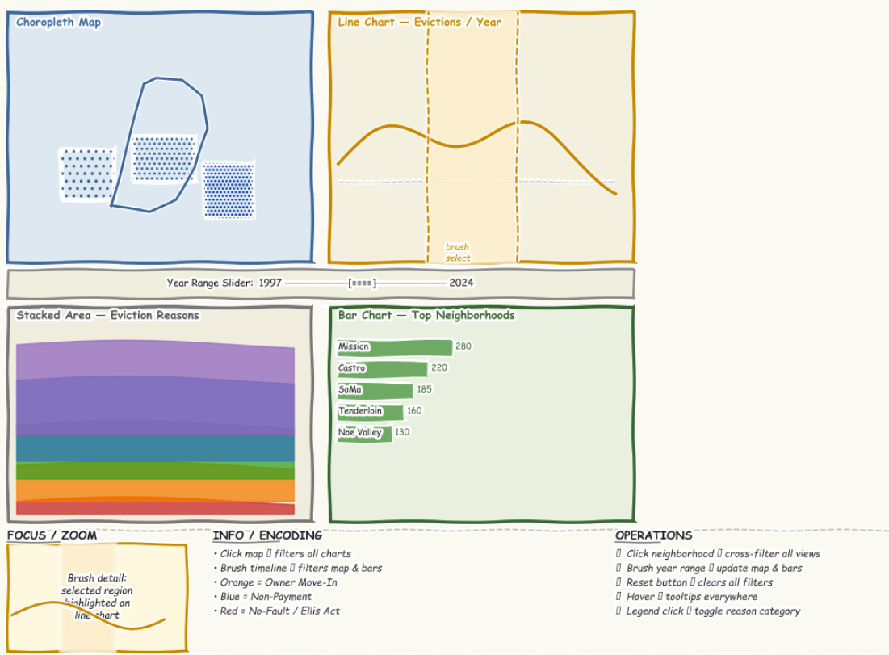
This design presents 4 views: a choropleth map, a line chart of total evictions per year , a stacked area chart of eviction reasons over time and a horizontal bar chart of top neighborhoods. A year range slider for filtering. The key interaction is cross-filtering: clicking a neighborhood on the map filters the stacked area and bar charts to that neighborhood, and brushing a year range on the line chart updates the map and bar chart to reflect only that period. This design gives the user full control to explore whatever dimension interests them. The only con is that there is no narrative guidance so it doesn't really help keep the same line for storytelling.
Layout 2
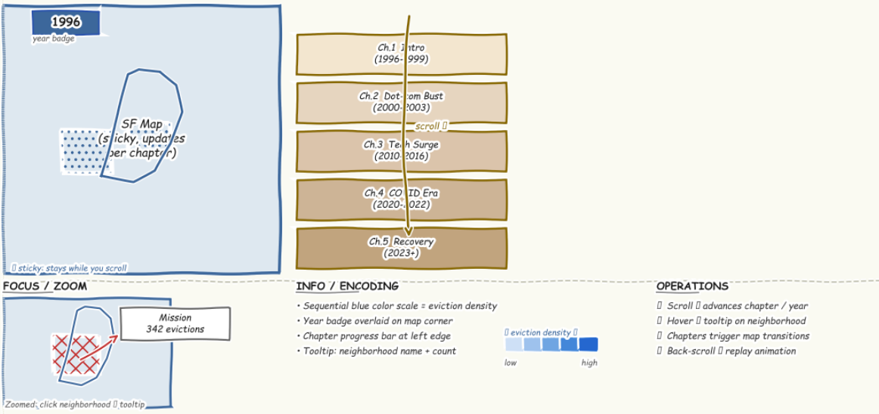

This design uses a vertical scroll structure. A choropleth map of SF neighborhoods stays fixed on the left side of the screen while five text chapters scroll on the right: Introduction, Dot-com Boom (1997–2003), Tech Surge (2010–2016), COVID Era (2020–2022), and Recovery (2023+). As the user scrolls into each chapter, the map transitions to show eviction density for that time period using a sequential blue color scale. This visualization guides the user step by step. The map stays visible at all times and is accompanied with context which helps for scrollytelling. The weakness is that it is strictly linear.
Layout 3
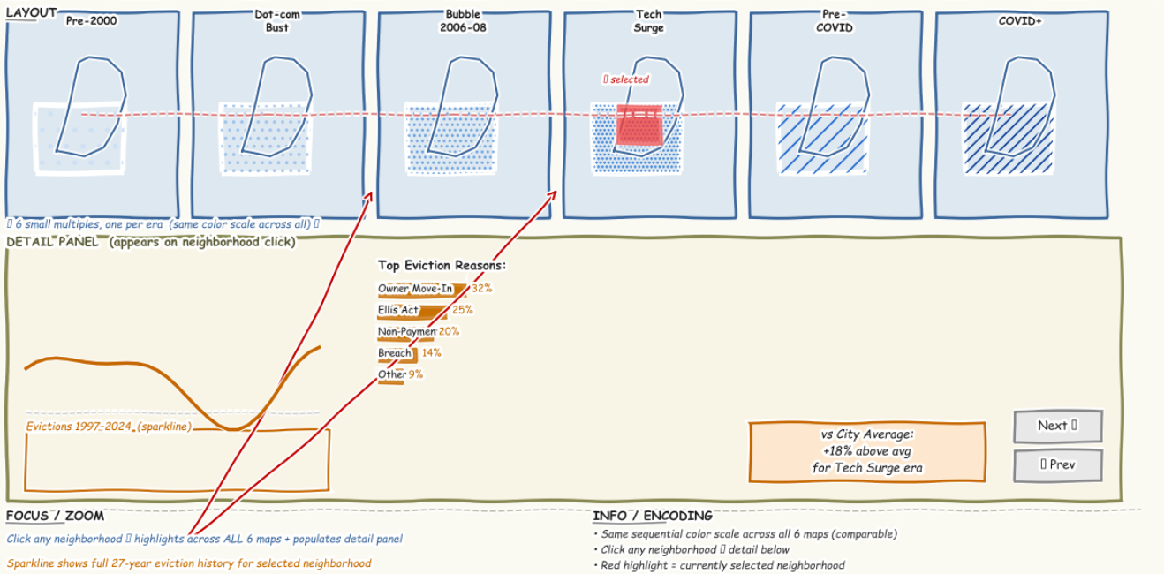
This design shows six small choropleth maps side by side, each representing a different era: Pre-2000, Dot-com & Bust, Housing Bubble, Tech Surge, Pre-COVID, and COVID. All six maps use the same sequential color scale, making it easy to visually compare how the geographic distribution of evictions shifted across eras. The strength here is the side-by-side comparison, which makes easier comparisons. The weakness is that small maps are harder to read and offer less detail per time period.
Final layout
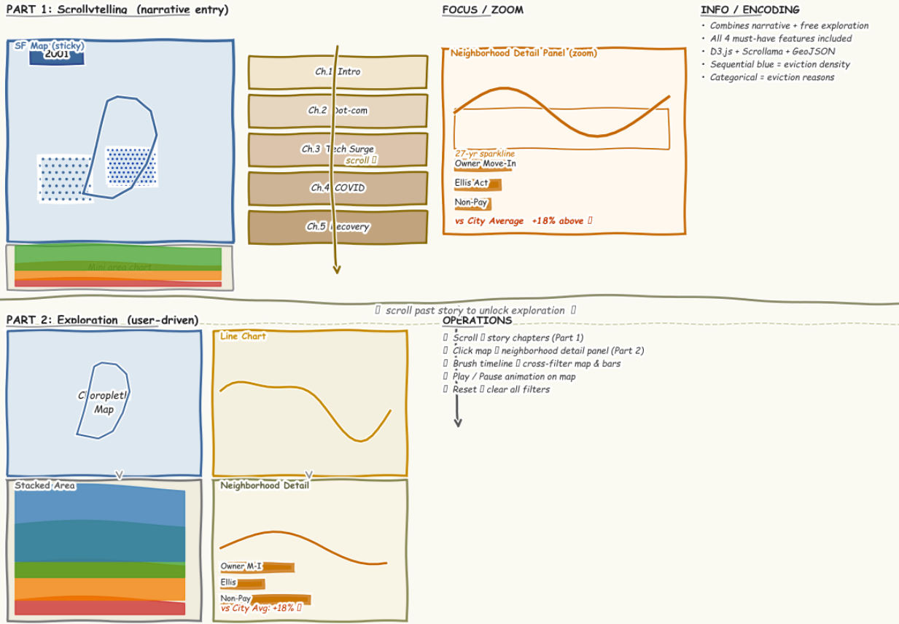
The final design combines the strongest elements from all three alternatives. It is structured in two parts. Part 1 is a scrollytelling narrative adapted. Then in Part 2 the transitions into a free exploration dashboard. This hybrid approach serves two audiences: users who understand the story, and data-curious users who want to dig into specific neighborhoods or time periods. All four must-have features (animated timeline map, eviction reason stacked area chart, scrollytelling narrative, and neighborhood detail panel) are incorporated into this final design.

7. Must-Have Features
Feature 1: Animated Timeline Map
Addresses: Objectives 1 & 2 (Temporal Trends, Geographic Displacement)
- An animated map of SF's 41 neighborhoods that transitions smoothly between years (1997-2026) as the user scrolls through the story sections.
- Color intensity (Sequential Blues scale) encodes eviction count per neighborhood per year. The map uses D3's geographic projection (d3.geoMercator) bound to SF neighborhood GeoJSON from DataSF.
- A manual timeline scrubber below the map allows users to jump to any year, with a play/pause button for continuous animation. The current year is displayed as an overlay badge.
- Hovering over any neighborhood displays a tooltip with the neighborhood name, eviction count for the selected year, and the dominant eviction reason

Feature 2: Eviction Reason Stacked Area Chart
Addresses: Objective 3 (Eviction Mechanisms)
- A stacked area chart showing the annual composition of eviction types from 1997 to 2026.
- The chart is synchronized with the map: scrolling advances the year marker, and clicking a neighborhood on the map filters the stacked area to show only that neighborhood's reason breakdown.
- Hovering over any band highlights that eviction reason across both the chart and the map, creating a cross-view linking experience.
- The chart uses D3's d3.stack() and d3.area() functions with the Set2 color palette, ensuring colorblind accessibility and categorical distinctness across all 6+ reason categories.

Feature 3: Scrollytelling Narrative Sections
Addresses: Objectives 1 & 4 (Temporal Trends, Policy Impact)
- Five narrative "chapters" implemented with Scrollama.js that trigger D3 transitions as the user scrolls: (1) Introduction, (2) Dot-com Boom 1997-2000, (3) Tech Surge 2013-2016, (4) COVID Moratorium 2020, (5) Post-COVID Recovery.
- Each chapter includes contextual text explaining the economic or policy event, with the map animating to the corresponding year range and key neighborhoods highlighted with stroke annotations.
- Policy-impact annotations appear as SVG text overlays on the map at key years like "SF Rent Board strengthens anti-harassment protections (2014)" and "COVID moratorium begins (March 2020)"; making policy cause-and-effect visible.
- The scrollytelling framework uses sticky positioning for the map/chart panel, so the visualization stays in view while text sections scroll by, creating a standard scrollytelling reading experience.

Feature 4: Neighborhood Detail Panel
Addresses: Objectives 2 & 3
- Clicking any SF neighborhood on the map opens a slide-in detail panel showing: (a) the neighborhood's complete eviction history as a mini time-series line chart, (b) a horizontal bar chart of its top eviction reasons, and (c) a comparison table showing the neighborhood vs. the city-wide average for key metrics.
- The panel includes a "Neighborhood vs. City" comparison showing whether the selected area has a higher-than-average share of Ellis Act evictions, Owner Move-In evictions, or overall eviction rate.
- A "Previous / Next Neighborhood" navigation allows users in exploration mode to step through neighborhoods without returning to the map, enabling quick comparison of similar or adjacent neighborhoods.

8. Optional Features
The following features are desirable
- Demographic Overlay: It's possible to use other input data like the Census Data (median household income, racial composition by tract) to the neighborhood-level eviction data. Overlay a secondary color dimension or toggle to show the correlation between displacement and neighborhood demographics.
- Address-Level Search: A search box where users can enter a San Francisco address and see a dot map of all eviction notices filed within a 0.25-mile radius, with a list of nearby notices sorted by date.
- Comparison Mode: A toggle that allows users to pin two neighborhoods side by side, showing their eviction histories. Useful for comparing a historically high-eviction neighborhood with a lower-impact area.

9. Project Schedule:
Here's the updated schedule with accurate deliverable descriptions:
Week | Dates | Deliverable Due | Tasks
Week 1 | Apr 3 – Apr 10 | Revised Proposal, Related Work, and Website (Apr 10, 100 pts) | Revise proposal based on professor feedback and highlight all changes. Add Related Work section with 5+ resources: search for scrollytelling examples (e.g., NYT's "Rent Burden," Urban Displacement Project), D3 choropleth tutorials, housing eviction visualizations, and Scrollama-based projects. Ensure GitHub Pages site is live at MirandaCavalie.github.io/data-vis with index.html linking to design1, design2, design3, and final pages. Include the GitHub Pages URL in the revised proposal PDF.
Week 2 | Apr 10 – Apr 17 | Alpha Release (Apr 17, 50 pts) | All static visualizations complete. In D3: SF choropleth map colored by total evictions per neighborhood, and line chart of eviction counts per year (1997–2026). Additional static charts (can use matplotlib/seaborn exports): stacked bar chart of eviction reasons, top 10 neighborhoods horizontal bar chart. Write GitHub Pages link, list which features from proposal are done (map, line chart, static charts), upcoming milestones (interactivity, scrollytelling, detail panel), and any bugs present (like the GeoJSON name mismatches, missing neighborhoods).
Week 3 | Apr 17 – Apr 30 | Beta Release (Apr 30 by 2pm, 100 pts) | All proposed functionality working: scrollytelling with 5 chapters (Intro, Dot-com, Tech Surge, COVID, Recovery) triggering map transitions, stacked area chart showing eviction reasons over time, dashboard cross-filtering, neighborhood detail panel with mini line chart + top reasons bar chart + city average comparison. Record 4-min video: title slide, introduction covering housing crisis motivation and 4 objectives, live demo walking through scrollytelling chapters and showing dashboard interactions, next steps (polish transitions, add annotations, responsive fixes). Submit all HTML, JSON, GeoJSON, and Python scripts.
Week 4 | Apr 30 – May 11 | Project Presentation (May 11, 50 pts) | Incorporate beta feedback from professor. Add any policy annotation overlays ("COVID moratorium begins March 2020"), legend improvements, tooltip consistency. Prepare slide deck (PDF): Introduction with housing crisis context + 4 objectives (2 min), live demo on GitHub Pages walking through each visualization and mapping it to its objective (4 min), updates since beta with screenshots of before/after changes (1 min), discussion of what worked (scrollytelling narrative) and challenges (GeoJSON neighborhood matching, stacked area edge cases) (2 min), future work, comparison mode (1 min). Practice to hit 8–10 minutes. Record practice video for 10 extra credit points.
Week 5 | May 11 – May 17 | Project Report Draft (May 17, 50 pts) | Write report in IEEE template on Overleaf. Introduction with housing crisis context and 4 objectives. Related Work citing 10+ references: scrollytelling papers, D3 choropleth examples, housing displacement studies, Scrollama docs, FdS methodology (Roberts 2011), similar DataSF projects. Approach section describing Python data pipeline (pandas cleaning, JSON aggregation), D3 implementation (geoMercator, d3.stack, IntersectionObserver), and design evolution with FdS sketches — include screenshots of failed approaches (e.g., early map without proper color scaling). Results with captioned screenshots. Discussion on scrollytelling vs. dashboard trade-offs and what I'd change. Future Work listing optional features not implemented. Visit USF Writing Center for proofreading.
Week 6 | May 17 – May 20 | Final Submission (May 20, 150 pts) | Submit zip containing: (1) Final IEEE report PDF with all revisions (50 pts). (2) Presentation slides PDF (25 pts). (3) Demo video walking through all 4 must-have features; animated timeline map, stacked area chart, scrollytelling chapters, neighborhood detail panel (25 pts). (4) All code commented explaining D3 bindings, data loading, and interaction logic (25 pts). (5) User manual. GitHub Pages deployment steps, interaction guide (25 pts). Test the user manual from a clean folder before submitting.

